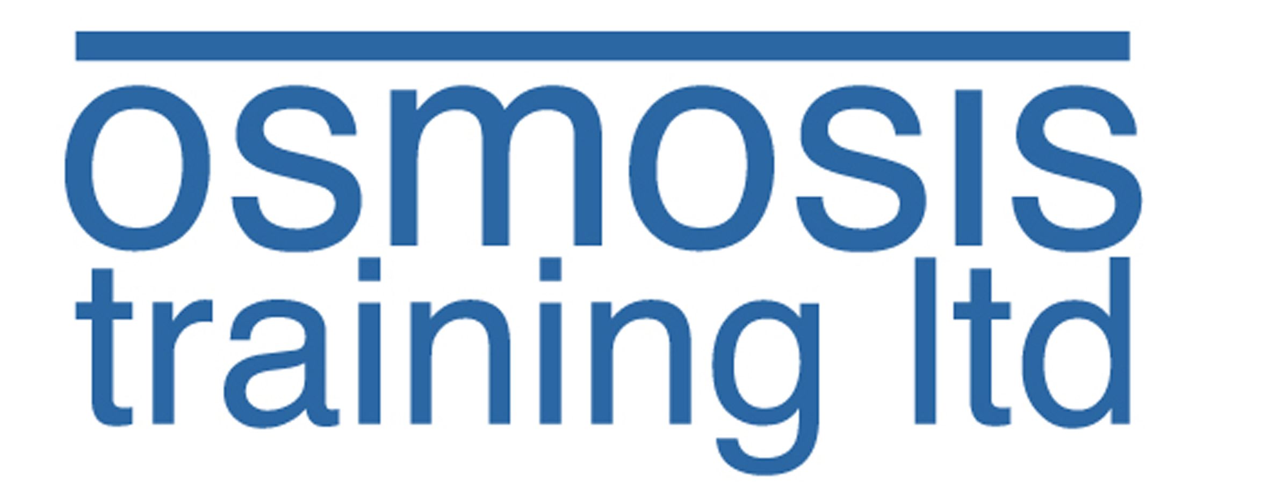
Osmosis Training New Training Location
(from 26th May 2009)

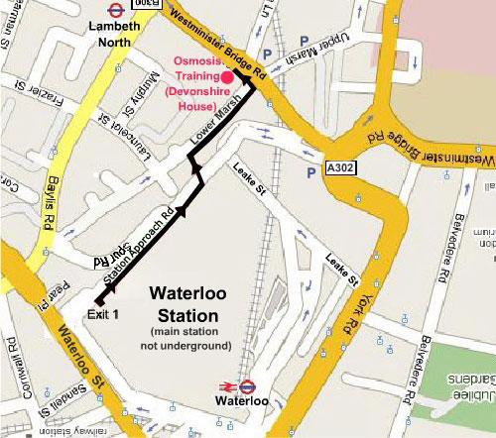

Devonshire House
Lower Ground Floor
164 - 168 Westminster Bridge Rd
Waterloo
London
SE1 7RW
0845 601 7313
contact@osmosistraining.co.uk

Walking directions from Waterloo Rail Station:

- Leave station from Exit 1 out of the main concourse (near platform 1)
- Turn Right, follow Station Approach Road and cross road where safe
- Turn Left down ramp to Lower Marsh
- Turn Right along Lower Marsh
- Cross over Lower Marsh road where safe
- Turn Left onto Westminster Bridge Road
- The Osmosis Training premises at 164 – 168 Westminster Bridge Road is the second building you will meet and is glass fronted with a dark mirrored effect.
- Please ring the buzzer and head downstairs via the lift or the stairs.

Walking directions from Waterloo Underground Station: Find your way to the main railway station and follow the above instructions

Directions via Lambeth North Underground Station – Bakerloo Line:

1. Turn Right outside the station
2. Cross over Baylis Road and keep walking straight ahead along Westminster Bridge Road
3. The Osmosis Training premises at 164 – 168 Westminster Bridge Road is the second to last building on the block and is glass fronted with a dark mirrored effect.
4. Please ring the buzzer and head downstairs via the lift or the stairs.

Parking – Please note the letter “Ps” which indicate parking locations at around £10 per day

